**Unsupervised cell interaction profiling based on multiplet RNA sequencing reveals major architectural differences between small intestinal and colonic epithelium.**

Jason T. Serviss1*, Nathanael Andrews1*, Agneta B. Andersson2, Ewa Dzwonkowska1, Rosan Heijboer2, Marco Gerling2,3 & Martin Enge1§

* Equal contribution

§ To whom correspondence should be addressed: [martin.enge@ki.se](mailto:martin.enge@ki.se)

1) Department of Oncology and Pathology, Karolinska Institutet, BioClinicum J6:30, Akademiska stråket 1, 171 64 Solna, Sweden

2) Department of Biosciences and Nutrition (BioNut), Karolinska Institutet, Hälsovägen 7, 141 83 Huddinge, Sweden

3) Tema Cancer, Karolinska University Hospital, 171 65 Solna, Sweden

**Abstract**

Cellular identity in complex multicellular organisms is strictly maintained over the course of life. This control is achieved in part by the organ structure itself, such that neighboring cells influence each other’s identity. However, large-scale investigation of the cellular interactome has been technically challenging. Here, we develop CIM-seq, an unsupervised and high-throughput method to analyze direct physical cell interactions between every cell type in a given tissue. CIM-seq is based on RNA sequencing of incompletely dissociated cells, followed by computational deconvolution of these into their constituent cell types using particle swarm optimization. We use CIM-seq to define the cell interaction landscape of the mouse small intestinal and colonic epithelium uncovering both known and novel interactions. Specifically, we find that the general architecture of the stem cell niche is radically different between the two tissues. In small intestine, the stem-paneth cell interaction forms an exceptionally strong and exclusive niche, in which paneth cells provide Wnt ligands1. In colonic epithelium, no similar compartment exists to support stem cells, and Wnt signaling is provided by a mesenchymal cell layer2,3,4. However, colonic stem cells are associated with a subset of goblet cells expressing the wound healing marker Plet1, suggesting an additional level of structural control in the colon. These results identify novel cellular interactions specific for the colonic stem cell niche and shed light on a previously unappreciated complexity of the tissue organization and biology of the colon. CIM-seq is broadly applicable to studies that aim to simultaneously investigate the constituent cell types and the global interaction profile in a specific tissue.

**Main**

Cells in higher order multicellular organisms are diverse and highly specialized. Such a level of specialization requires strict control, which is in part encoded in their spatial organization1,5. Single-cell RNA-seq (scRNA-seq) methods have enabled rapid advances towards determining the full complement of cellular diversity in human and mouse tissue6. However, no similar high throughput and unbiased method exists to chart the fine-grained structural diversity of how these cells interact, or to profile interaction-dependent changes in gene expression. To this end, we developed Cell Interaction by Multiplet sequencing (CIM-seq), a method that allows large-scale interaction profiling within a well-established scRNA-seq framework.

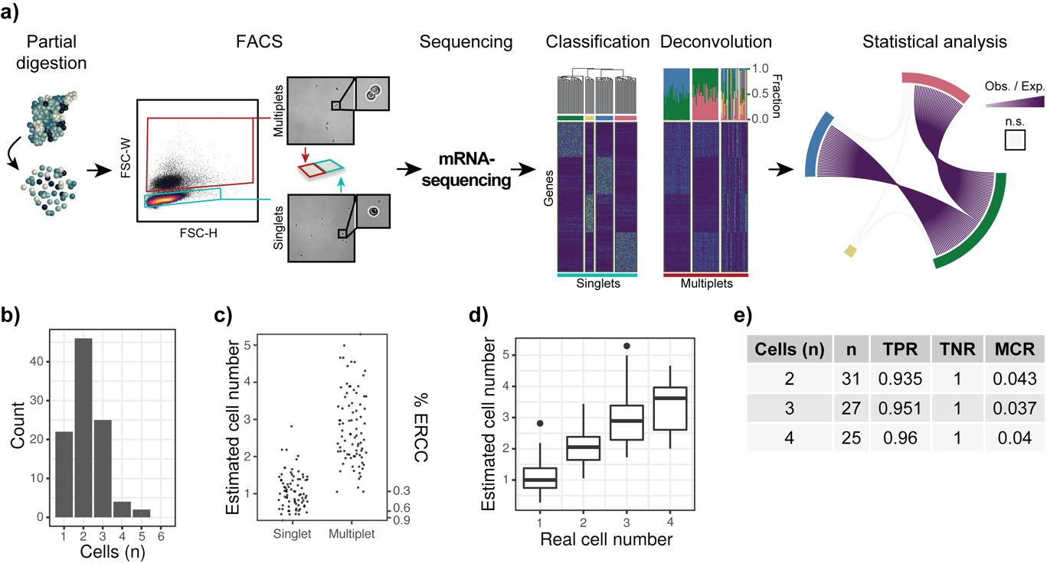

**Figure 1. CIM-seq allows unbiased determination of physically interacting cells types. a)** Summary of the method. Solid tissue is partially dissociated into single cells and cell multiplets, sorted separately, and analyzed using scRNA-seq. Each multiplet is computationally deconvoluted into its most-likely single cell constituents. Statistical enrichment of co-occurring cells in a large cohort of multiplets indicates physical interaction in the tissue. **b)** Distribution of cell numbers per multiplet as determined by phase contrast microscopy. **c)** % ERCC corresponding to estimated cell numbers for singlets and multiplets, **d)** ERCC-based cell number estimation correlates well with real cell numbers in multiplets with known cell composition. **e)** Error rates of multiplets with known cell composition. Mean true positive rate (TPR), mean true negative rate (TNR) and mean misclassification rate (MCR) is shown for each multiplet cell number.

scRNA-seq methods generally rely on a suspension of dissociated cells where those cells which are not fully dissociated from each other (multiplets) are removed7. In CIM-seq, we

repurpose these multiplets to determine which cells physically attached to each other in the intact tissue. RNA-seq libraries prepared from such cell multiplets represent a mix of unknown quantities of cells that exist in the tissue, and their transcriptional profile can therefore be closely approximated *in silico* by combining scRNA-seq data from the constituent cell types. Thus, a multiplet profile can be computationally deconvoluted into fractional contributions of single cells, given a set of available singlet transcriptional profiles, and an estimation of the number of cells that constitutes the multiplet. CIM-seq accomplishes this in three separate stages (Fig. 1a). In the first step, we perform partial dissociation of the target tissue, followed by cell sorting of singlets and multiplets into multiwell plates and conventional Smart-Seq2 library preparation8. Second, we use the singlet sequence data to perform automated feature selection followed by graph-based clustering to construct a blueprint of cell types and states in the tissue. In the third step, we employ computational deconvolution to perform a maximum likelihood estimation (MLE) that determines each multiplet’s most likely cell type constituents based on the previously defined blueprint. Specifically, the MLE function uses particle swarm optimization9 to empirically determine which combination of the cell types has the highest likelihood of producing the observed multiplet expression profile (see *methods* for details). By examining the cell types contained in many multiplets we can create a map of cell interactions in the intact tissue.

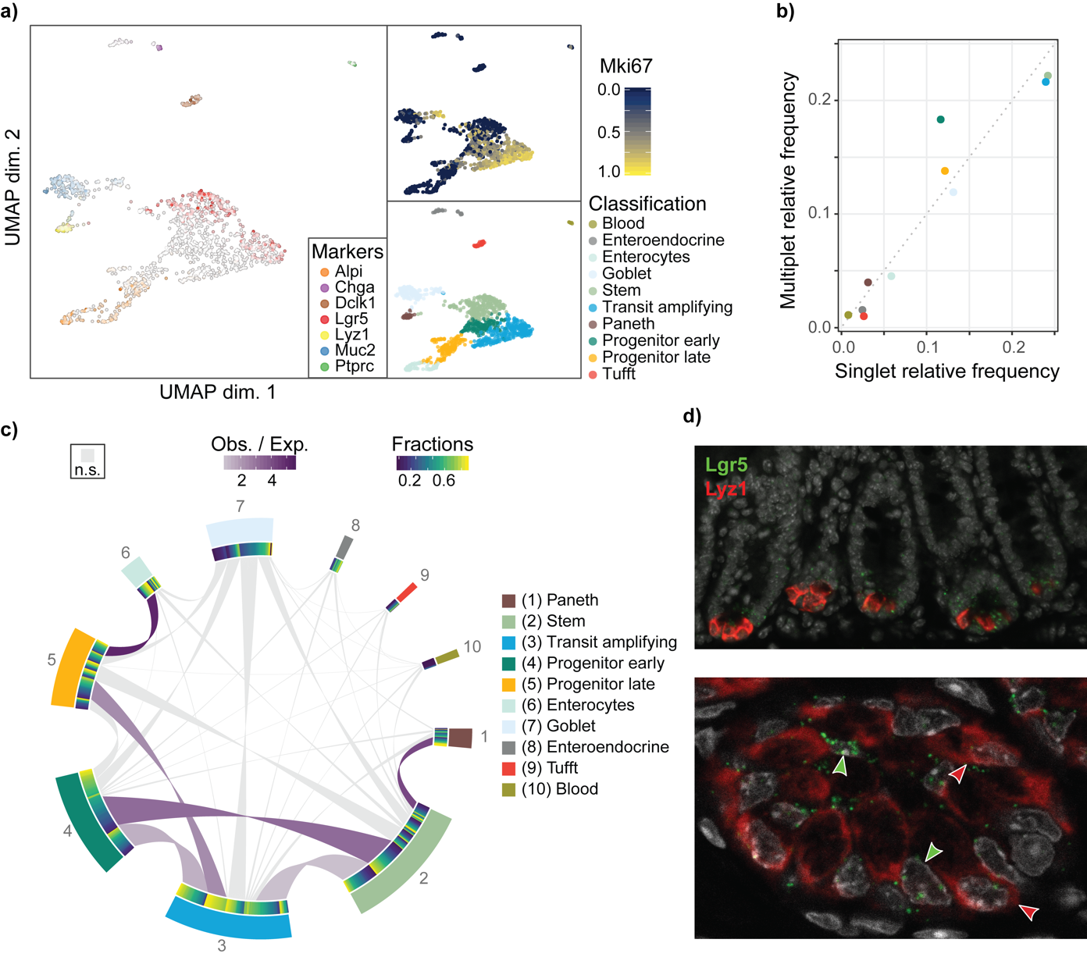

**Figure 2. CIM-seq accurately determines the small intestinal stem cell niche architecture. a)** scRNA-seq analysis of mouse small intestinal epithelium. Mki67 is log2(CPM + 1) and normalized to [0, 1]. **b)** Cell type frequencies in singlets and deconvoluted multiplets. **c)** Multiplet deconvolution analysis of small intestinal epithelium. **d)** Small intestinal stem cell niche visualized by mRNA staining.

Figure 2: “Tuft cells”, not “Tufft cells”

We first tested the propensity of cell singlets to re-associate in suspension, which would result in connections that do not reflect physical attachment in the tissue. Singlet identity remained stable over time, with singlet re-association below 0.5% after 2h (Extended Data Fig. 1a). Examining the FACS-sorted multiplets revealed that the majority consisted of 2-3 physically connected cells, as verified by microscopy (Fig. 1a-1b). To measure the performance of CIM-seq in a controlled setting, we used three distinct cell lines (A375 [melanoma], HCT116 [colon cancer], HOS [osteosarcoma]) and sorted these as either singlets or multiplets of a known composition. The final dataset included 79 singlets and 83 multiplets (multiplets consisting of 2-4 cells were present in approximately equal proportions). The number of cells can be estimated by comparison of cellular mRNA counts to ERCC (External RNA Control Consortium) control RNA10 spiked in at a known concentration (Fig. 1c) and predicts the actual number of cells well (Fig. 1d). Cell type specific markers were observed to be exclusively co-expressed at appreciable levels in multiplets (Extended Data Fig. 1b). Standard dimensionality reduction (uniform manifold approximation and projection, UMAP11) and graph-based classification identified the individual cell types (Extended Data Fig. 1c) forming the blueprint for the deconvolution step. The deconvolution revealed a very high level of correspondence between the expected and detected connections with a <5% average error rate for each of the examined cell compositions (Fig. 1e, Extended Data Fig. 1d-1e).

To test the feasibility of performing interaction profiling in a complex tissue, we analysed mouse small intestinal (SI) epithelial crypts, in which the organization of different cell types along the crypt-villus axis is known12–15. SI stem cells reside at the bottom of intestinal crypts and their stemness is critically maintained by interaction with postmitotic, Wnt3-producing paneth cells. Upon stem cell division, one of the daughter cells is pushed upwards towards the lumen, losing contact with the paneth cell and thereby initiating the process of differentiation into the cell types of the SI. We asked whether CIM-seq would be able to identify the paneth-stem cell interaction in an unsupervised manner. Therefore, we sequenced 1213 single cells from three mice, and performed unsupervised classification of the scRNA-seq data, which readily identified the cell epithelial subtypes of the small intestinal crypts16. The dimensionality reduced representation of the data showed Lgr5+ stem cells gradually transitioning into enterocytes, and correctly separated the other major cell types (goblet, paneth, enteroendocrine, and tuft cells) of the small intestine (Figure 2a). The multiplet deconvolution relies on classes being well defined, and could potentially fail due to class ambiguity. We evaluated the quality of the classification by a) examining other known covariates that do not correspond to cell type (Extended Data Fig. 2a), b) identifying differential gene expression between all of the individual classes (> 20 genes with an area under the curve of 0.7 or greater), and c) demonstrating that the classes are highly distinguishable by the deconvolution algorithm by deconvoluting the singlets and recovering the correct class in 96% of the cases (Extended Data Fig. 2b). In summary, these results indicate that the classification procedure identified specific cell types and cell states that are distinguishable by their gene expression profile.

We subsequently performed CIM-seq deconvolution of 435 multiplets isolated from the same cell suspensions as the singlets. The majority, 74%, of the multiplets were estimated to contain 1-4 cells based on ERCC spike in ratio, confirming the distribution determined by visual inspection (Fig. 1b). Cell type frequencies inferred by multiplet deconvolution were similar to the frequencies we found in the singlet data set (Fig. 2b), indicating that there were no systematic errors in multiplet selection or deconvolution. Importantly, when the analysis was performed in conjunction with colonic tissue, no significant cross-connections were identified indicating a low frequency of false positive connections (Extended Data Fig. 2c). To find cell types with a specific preference for interaction partners, we determined the statistical enrichment of every pairwise cell type connection (see *methods* for details). Cell types that are scattered throughout the crypt, such as goblet cells, were rich in interactions but had no specific connecting partners (Fig. 2c). Paneth cells and stem cells, on the other hand, represented a highly enriched connection (the most significant connection after the late progenitor and enterocyte connection), with 80% of the total paneth cell connections being to a *Lgr5*+ cell type. RNA in situ hybridization (ISH) of the stem cell marker *Lgr5* and paneth cell marker *Lyz1* confirmed the direct adjacency of the cells *in vivo* (Fig. 2d). Thus, the paneth and stem cell connection represents a highly specific interaction in our analysis, in agreement with its role in maintaining stem cell identity by direct interaction.

The colonic epithelium has a similar crypt structure to SI, with Lgr5+ stem cells located at the base of the crypt and differentiating into broadly equivalent cell types (colonocytes, goblet cells, enteroendocrine, tuft). However, the architecture of the colonic crypt has not been characterized to an equally thorough resolution - for example, paneth cells are fundamental to the SI stem cell niche but it is undetermined if there is an equivalent cell type in the colon17,18. To directly compare the architectural properties of the two tissues, we analyzed 2467 single cells and 1703 multiplets from colon using CIM-seq. The colonic epithelium displayed a much higher fraction of goblet cells, in agreement with previous observations19 , and the goblet cells were more diverse, organizing into four different classes identified by unsupervised classification (Fig. 3a). Notably, two of these classes expressed the wound-healing marker Placenta expressed transcript 1 (*Plet1,* Extended Data Fig. 3a top right panel). Even with the higher level of cell type complexity, the deconvolution-inferred cell type frequencies mirrored singlet frequencies (Fig. 3b). Connection enrichment analysis revealed a similarly strong link between terminally differentiated colonocytes and late-stage differentiating cells (Fig. 3c). Although colonocytes were strongly connected to late-stage differentiating cells, they were more highly connected to other classes in colon than enterocytes in the SI, potentially reflecting a less pronounced

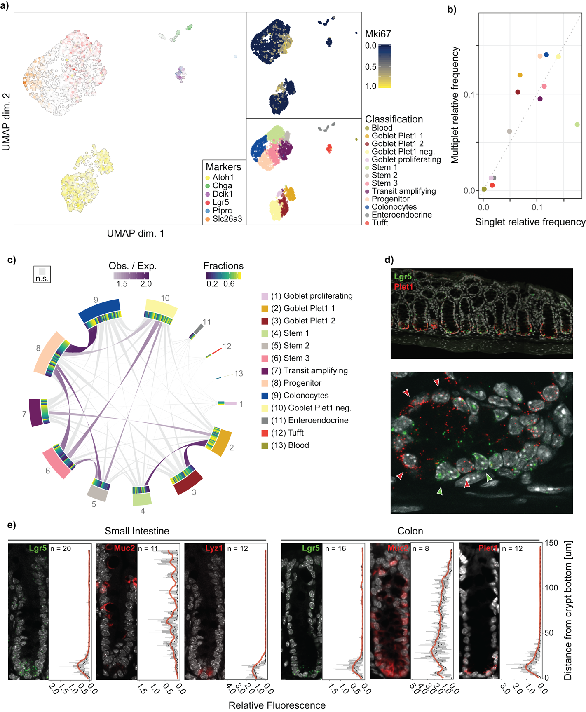

**Figure 3. Interaction analysis of the colonic crypts reveals Plet1+ goblet cell - stem cell interaction. a)** scRNA-seq analysis of the colonic singlets. Mki67 is log2(CPM + 1) and normalized to [0, 1]. **b)** Cell type frequencies in singlets and deconvoluted multiplets. **c)** Multiplet deconvolution analysis of colonic epithelium. **d)** *In vivo* staining using stem cell marker Lgr5 and Plet1. **e)** Distribution of stem (Lgr5), paneth (Lyz1), goblet (Muc2) and Plet1 in the small intestine and colon crypts visualized via RNA-Scope.

compartmentalization due to the more compact structure of the colon, which lacks the large villus structures of SI.

The goblet cell sub-clusters displayed two distinct interaction patterns. Plet1+ goblet cells interacted strongly with the most highly Lgr5-expressing cell cluster, whereas Plet1- goblet cells preferentially interacted with more differentiated cell types (Fig. 3c). In line with this, the probability of observing *Lgr5* expression was >3-fold higher in multiplets containing goblet cells that express *Plet1* compared to *Plet1* negative counterparts (Extended Data Fig. 3b). mRNA ISH verified that the Lgr5+ stem cells were located adjacent to Plet1+ cells in the intact tissue (Fig. 3d). Quantification of ISH stainings confirmed localization of Plet1+ cells specifically to the crypt base, in direct proximity to Lgr5+ cells, mirroring the pattern of Lyz1+ cells in the SI (Fig. 3e). Hence, CIM-seq discovered a specific goblet cell type, characterized by the expression of *Plet1*, that interact with Lgr5+ stem cells in the colon stem cell niche.

Previous research is inconclusive concerning the existence of a colonic cell type that is equivalent to the SI paneth cell. It has been suggested that there is either a similar stemness-inducing cell type20,18, or that the colonic epithelium relies largely or entirely on stromal signalling to maintain stemness4,3. In order to investigate the possibility that the Plet1+ goblet cells are a source of stemness signalling in the colon, we began by examining the expression of Wnt ligands, which are essential stem cell factors in the intestinal epithelium. We found that those Wnt ligands previously reported to be pivotal for intestinal stem cell maintenance were largely absent in the epithelium of both the SI and colon, with the exception of *Wnt3*, which was exclusively expressed by paneth cells of the SI (Fig. 4a)3,21. Stem cells and transit amplifying cells, in both SI and colon, had high expression levels of multiple Wnt targets indicating that Wnt signalling is active in these cells and prompting further investigation into sources of Wnt ligands (Fig. 4a)22. RNA ISH confirmed epithelial *Wnt3* expression in SI crypts, while *Wnt2b*, another Wnt ligand reported to be expressed in the intestine, was found in the stroma of both the SI and colon, confirming previous results (Fig. 4b)3. Among the other known factors that are thought to shape the intestinal stem cell niche, *Notum* had a high specificity for SI paneth cells, whereas Delta-like 2 (*Dll2*) and *Dll4* were expressed by multiple cell types in the SI and colon including Plet1+ goblet cells, SI goblet cells, and colonic Plet1- goblet cells (Fig. 4b)23. When comparing the expression of *Plet1* to that of *Reg4* and *cKit*, two other genes proposed to mark niche cells in the colonic crypt, we found that *Reg4* and *cKit* were promiscuously expressed compared to *Plet1* (Fig 4b)17,18. Thus, our results indicate that Plet1+ goblet cells are unlikely to be a specific source of stemness signaling in the colon. However, this data points to significant differences in the compartmentalization of Wnt driven maintenance of stem cell identity in the SI and colon, and strongly supports previous results indicating that colonic Wnt ligands originate exclusively in the stroma2.

*Plet1* encodes a membrane-bound glycoprotein (PMID: 20130590) that plays a role in cell migration after injury24–26and that is functionally important for tissue repair upon damage of the intestinal epithelium,. Differential expression analysis of Plet1+ goblet cells revealed genes with known roles in cell-cell adhesion (*Cgref1*, *Cd44*, *Lgals9*), as well as tissue organization and inflammation (*Ang*, *Ccl9*) to be highly expressed in Plet1+ cells (Extended Data Fig. 3a). Therefore, we next analyzed *Plet1* expression during regeneration of the colonic epithelium after chemically induced intestinal injury. We found that *Plet1* was highly expressed in apical cells of the regenerative epithelium , where *Plet1* expression was highly upregulated (Fig. 4c). By contrast, in areas of the proximal colon that remained histologically largely unaffected by DSS, Plet1 mRNA remained located exclusively to the crypt, adjacent to Lgr5 mRNA. In regenerative areas, Lgr5+ cells located to the crypt bottom, albeit Lgr5 mRNA was increased. Ki67 immunostaining confirmed increased levels of proliferation in regenerating crypts and a shift of the proliferation zone to luminal cells, where highly upregulated Plet1 expression was seen. Together with previous data24, these results support a role for Plet1+ cells in intestinal damage repair and in the maintenance of intestinal tissue integrity. It is tempting to speculate that Plet1+ crypt cells could give rise to highly motile epithelial cells that repopulate damaged epithelium. Alternatively, Plet1 is expressed ectopically by differentiated cells to aid wound repair. In either case, the results indicate that Plet1+ crypt goblet cells could represent a highly motile cell population equipped to respond to epithelial damage, rather than providing niche signals to colonic stem cells.

Recently, several methods that allow analysis of highly multiplexed gene expression and spatial information have been developed. Multiplexed mRNA staining methods27–29 generally provide very high spatial accuracy, allowing for cellular or even sub-cellular localization of transcripts, while sacrificing the number of genes that can be interrogated. Importantly, the constraint that the set of genes to measure is determined beforehand limits their use to testing known hypotheses rather than generating novel ones, although higher multiplexing allows a large set of hypotheses to be tested in parallel. Array based methods are not limited to a

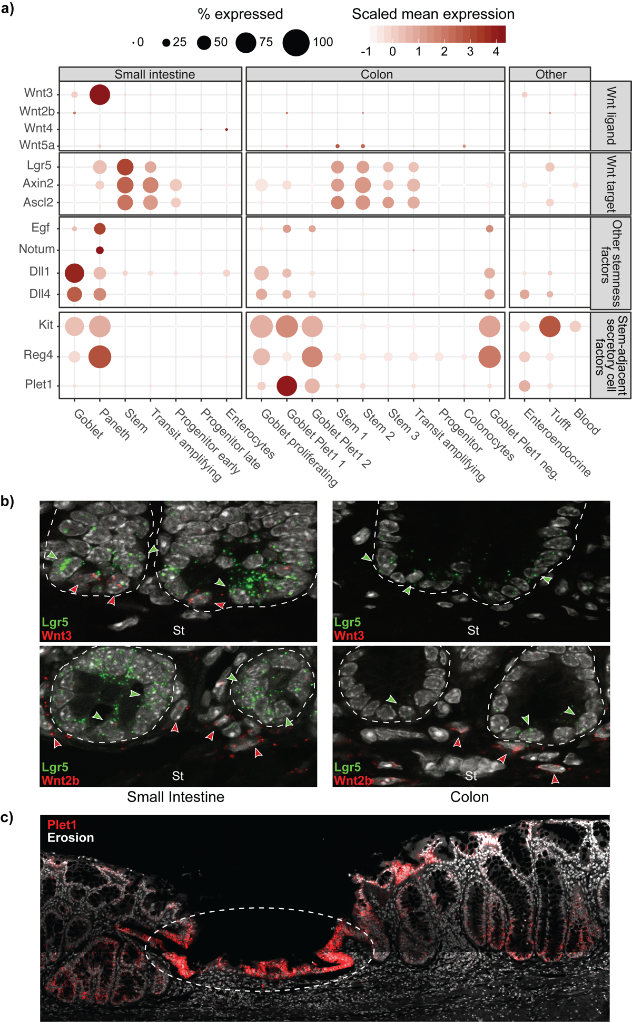

**Figure 4. Colonic epithelium relies on external Wnt signaling. a)** Expression of Wnt ligands (top panel) is restricted to paneth cells in small intestinal epithelium, whereas downstream target genes (bottom panel) are active in both tissues. **b)** RNA staining of Wnt3 and Wnt2a (red), and Lgr5 (green). Stroma (St). **c)** *Plet1* RNA ISH in mouse colon after injury induced by DSS treatment.

predefined set of genes, but are instead typically limited in spatial accuracy by the size of the barcoded features and diffusion rate of mRNA molecules precluding true single-cell accuracy30,31. Also, these methods are based on proximity rather than physical attachment which limits the ability to associate such interactions with specific changes in gene expression. A method based on manually separating interacting cells and performing scRNA-seq on each interacting partner has also been proposed32. While providing excellent data on direct interaction, the reliance on specialized equipment and high labor intensity of this method makes it impractical for general use.

CIM-seq solves many of the problems of previous methods. All transcripts are measured, similarly to the index based methods, but with the advantage that multiplets are investigated with no loss of sensitivity compared to conventional scRNA-seq. Since CIM-seq relies on actual physical interaction of cells in intact tissue, it has single-cell spatial accuracy. Also, it is based on a widely used and easy to automate scRNA-seq protocol, making it easy for labs to adopt at a large scale. Its major limitation is that it only allows us to obtain information on direct interactions and cannot detect higher-order structures, which may be important for organ development by, for example, creating a concentration gradient of signaling molecules in the tissue.

Detection of cell type interaction relies on statistical enrichment analysis to identify the type of preferential interactions between two cell types suggestive of functional co-dependence. Highly specific and exclusive interactions between transcriptionally different cells, such as the paneth/stem cell interaction in small intestine are evident even without formal statistical enrichment analysis. However, most interactions are specific but non-exclusive (e.g. the interaction between Plet1+ goblet cells and Lgr5+ stem cells in colon) and for these, statistical enrichment analysis is necessary to account for the vast differences in cell type frequency. This also means that cell types that interact broadly in a tissue (e.g. goblet cells in the small intestine) are easily identifiable as having many non-significant interaction partners and the number of connections are well correlated with cell frequency.

CIM-seq is a general method broadly applicable to any solid tissue, and we expect it to be useful in a wide variety of scientific questions. This includes organ development and developmental diseases, decrease of fitness in aging which has been partly attributed to loss of organ integrity, and tumor-stromal interactions in malignancies. Thus, we anticipate that CIM-Seq will be a useful tool to generate novel hypotheses about how specific cell interactions influence cell function and identity.

**Methods**

***Cell lines***

All cell lines were purchased from ATCC and verified and mycoplasma tested before use.

***Mice***

C57BL/6J mice eight months of age or older were used for isolation of small intestinal and colonic epithelial cells. Breeders were bought from Scanbur, Sweden. Mice were housed in specific pathogen free conditions with free access to water and standard chow food. Night-day cycles were 12 hours. All experiments and breedings were approved by the local animal ethics committee (The Board of Agriculture, Sweden).

***Intestinal injury model***

DSS (approximate molecular weight 40kDa, DB001-38; Tdb Consultancy, Sweden) was initiated at a concentration of 3.5% w/v and administered in drinking water day 1 (d1) to d5. Animals were sacrificed on d8, colons were harvested, fixated in 10% w/v buffered formalin (158127; Sigma-Aldrich, USA) at room temperature overnight and subjected to paraffin embedding.

***Crypt isolation for CIM-Seq***

Small intestine and colon were  removed from C57BL/J wild-type mice and kept on ice in phosphate buffered saline (PBS). Lumina of colon and small intestine were washed three times with PBS and adipose tissue connected to the exterior of the small intestine or colon was removed. Colon and small intestine were opened longitudinally, and any remaining mucous on covering the epithelial layer was gently rubbed off. Tissues were washed once in PBS before being cut into 0.5 - 1 mm long fragments. Colon fragments were immersed in 10mM EDTA-PBS and incubated for 105 minutes on ice, with shaking every 15 minutes. Small intestinal fragments were similarly immersed in 10mM EDTA-PBS on ice and shaken. After 15 minutes, small intestinal fragments were allowed to settle at the bottom and the supernatant was discarded and replaced with new 10mM EDTA-PBS and shaken vigorously. This procedure was repeated 1-2 times, with supernatant fractions investigated through light microscopy before discarding, in order to enrich for crypts. Small intestinal fragments were then incubated on ice for 45-60 minutes for a total of 105 minutes. Following EDTA-PBS treatment fractions were triturated 10-15 times. Colon fractions were strained through a 100 um filter while small intestinal fractions were strained through a 70 um filter. Fractions were centrifuged at 300g for 5 minutes and dissociated using TrypLE Express (Invitrogen) at 37°C for 15-20 minutes. Enzymatic dissociation was supervised using light microscopy during regular intervals to obtain an appropriate amount of single cells and multiplets. Dead cells were removed using Dead Cell Removal Kit (Miltenyi Biotec) according to the manufacturer's protocol before staining for FACS sorting was performed.

***Cell sorting***

Cells were stained with FITC anti-CD326 and 7AAD (Sony Biotechnology) in order to monitor number of epithelial cells and select live cells. Additionally, paneth cells were enriched using Brilliant Violent anti-CD24. Single cells were distinguished from multiplets using FSC-H and FSC-W gating and the gating scheme was visually confirmed via phase contrast microscopy (Fig. 1a). Cells were sorted into 384- or 96-well plates containing hypotonic lysis buffer using a SH800S FACS sorter (Sony). Plates were sealed immediately after sorting with microseal F foil (Biorad) and centrifuged at 4000g at 4°C for 5 min before being frozen on dry ice and stored at -80°C.

***scRNA-seq***

Single-cell and multiplet RNA-Seq libraries were generated as described8. Briefly, single-cells collected in 384-well plates were lysed, followed by reverse transcription with template-switch using an LNA-modified template switch oligo to generate cDNA. After 21 cycles of pre-amplification, DNA was purified and analysed on an automated Fragment Analyzer (Advanced Analytical). Each cell’s cDNA fragment profile was individually inspected and only wells with successful amplification products (concentration higher than 0.06 ng/ul) and with no detectable RNA degradation were selected for final library preparation. Tagmentation assays and barcoded sequencing libraries were prepared using Nextera XT kit (Illumina) according to the manufacturer's instructions. Barcoded libraries were pooled and subjected to 75 bp paired-end sequencing on the Illumina NextSeq 500 instrument.

Sequencing reads were trimmed, adapter sequences removed and the reads aligned to the hg19 reference assembly using STAR33 with default parameters. Duplicate reads were removed using picard34. Transcript counts were obtained using HTSeq35 and hg19 UCSC exon/transcript annotations. Transcript counts were normalized into log transformed counts per million. Single cell profiles with the following features were deemed to be of poor quality and removed: 1) cells with less than a specified total number of valid counts in exonic regions (1.8x104 and 4x104 for the mouse gut and sorted multiplets dataset, respectively), 2) cells with low actin TPM, and 3) cells with high fractions of ERCC reads. To determine a cut-off for actin TPM, we used the normal distribution with empirical mean and standard deviation from log2 transformed actin TPM, which is normally distributed in successful experiments. The cut-off was set to the 0.01 quantile (eg. the lower 0.01 % of the bell curve). A similar strategy was used for fractions of ERCC reads, samples with a log2 transformed fraction of ERCC reads above the 0.99 % quantile were rejected. In total 3680 singlets (out of 4125 analysed wells, 89% success rate) and 2138 multiplets (out of 2452, 87% success rate) were retained for further analysis in the mouse gut dataset. In total 79 singlets (out of 96 analysed wells, 82% success rate) and 83 multiplets (out of 96, 86% success rate) were retained for further analysis in the sorted multiplets dataset.

***CIM-seq***

CIM-seq is implemented in the R statistical programming language36 and is freely available at ([https://github.com/EngeLab/CIMseq](https://github.com/jasonserviss/CIMseq)) under a GPL-3 license. The CIM-seq method consists of three distinct stages; a preparatory stage, including feature selection, dimensionality reduction, and classification, followed by a deconvolution stage, and an interaction enrichment testing stage.

*Preparatory stage*

CIM-seq permits the elements of the preparatory stage to be carried out using appropriate methods selected by the end user. For the analysis of the data included here we choose to utilize the Seurat37 package version 2.3.4 for all three preparatory stage elements; i.e. feature selection, dimensionality reduction, and classification. The standard Seurat workflow was followed but briefly outlined here. Dimensionality reduction for visualization was performed using the UMAP algorithm. Unsupervised classification of cell types and cell states was performed using a graph-based method. Briefly, data was scaled and centered using the *ScaleData* function after which feature selection was performed using *FindVariableGenes* function, selecting only those genes with a mean expression of 0.5 or 1 and dispersion > 1 and otherwise using default parameters. Principal component analysis with the resulting features was performed followed by jack straw testing to determine significant (p < 0.001) principal components. Significant principal components were subsequently used as input to the graph-based classification algorithm via the *FindClusters* function. Specifically, the louvain community detection algorithm was utilized to detect cell types with 100 random starts. Classification was often performed in an iterative fashion with various settings of the resolution parameter with final classifications judged to be sufficient based on the partitioning of known cell types and marker genes. Feature selection for downstream deconvolution was carried out via the *FindAllMarkers* function using the AUC test and setting the minimum difference in the fraction of detection parameter to 0.2 or 0.4 and log fold change threshold to log(2).

*Deconvolution stage*

In the deconvolution stage the goal is to determine the fractional contribution of the various cell types, discovered in the preparatory stage, to each individual multiplet and, in this way, determine their cellular composition. The deconvolution takes advantage of particle swarm optimization (PSO) where [0, 1] constrained candidate solutions (swarm particles), consisting of a vector of fractions with one value per cell type, are optimized with respect to a cost over a number of iterations. PSO makes few assumptions about the problem being optimized, and does not require a differentiable optimization problem, while still being able to search a large space for candidate solutions38.

The CIM-seq cost function is based on the probability, p(m | s,c), of observing the gene expression profile of a multiplet (m), given a candidate solution (s), and the singlet gene expression profiles from each class (c). The probability is determined empirically by creating a number of *in silico* multiplet profiles derived from gene expression values of one randomly selected singlet from each class (cv, synthetic multiplets), multiplied by the candidate solution vector (s), and summed over all classes. Each of these gene expression point values are treated as individual poisson processes with λ = round(s * cv) with the joint point p-value (probability mass function, pmf) for a gene j in m (mj), over n randomly generated multiplets given by:

Equation (1)

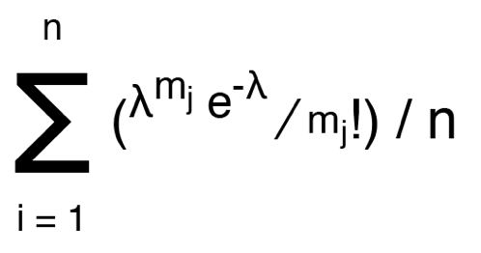

The cost is defined as the sum of the -log10 probabilities, p(m | s,c), given by Equation (1). The final result of the deconvolution procedure gives one solution, a vector of fractions, per multiplet and a corresponding cost.

Converting the solution vector of fractions into connections was achieved by first normalizing the elements of the solution vector corresponding to each cell type by the ERCC-estimated median relative RNA contribution for each cell type. Fractions are then multiplied by the ERCC-estimated cell number for each multiplet to take into account the number of estimated cells in the multiplet and then subsequently rounded to the nearest integer. Due to the inherent noise in the ERCC data, outlier multiplets (< 5%) will appear to contain an exceptionally large number of cells. In order to limit false positive connections in the deconvolution results, the estimated cell number in the multiplets was limited to 4, based on microscope observations (Fig. 1b). The resulting matrix from this procedure was then binarily transformed by converting all integers greater than 0 to 1 which indicates a connection between the corresponding cell types.

CIM-seq uses a modified SPSO2007 reference implementation of the PSO algorithm with two additions designed to improve performance when used in conjunction with CIM-seq. These modifications include 1) increased user control over early stopping criteria allowing for early termination of the optimization and 2) acceptance of user supplied swarm particle starting positions. For 1) we allowed early termination in the case that the cost did not improve by 1 (costs tend to be on the scale of thousands) in 5 iterations for all deconvolutions. For 2), we supplied precalculated swarm positions for all possible cell class combinations of one and two and added random normally distributed noise with a mean of 0 and standard deviation of 1 / the number of cell classes. In each of the deconvolutions we allow a maximum iteration of 100 with a minimum of 400 swarm particles and 2000 (Mouse gut dataset) or 400 (sorted cell lines dataset) synthetic multiplets are provided to the cost function.

*Interaction enrichment testing stage*

We assume that if connections are randomly distributed between cell types that the number of connections between two individual cell types would follow the relative abundance of those cell types. Therefore to calculate the expected number of connections between any two cell types, we first estimate the relative abundance of each cell type based on the data from the deconvoluted multiplets. Subsequently, for each cell type, we calculate the expected number of connections between that cell type and every other cell type by multiplying the relative abundance of each of the other cell types by the total number of detected edges from the cell type under consideration. The enrichment score for a specific interaction is then calculated as the quotient of the number of observed edges and the number of expected edges.

Hypothesis testing to evaluate the probability of observing a greater number of interactions than the observed number, P[I > i],  is evaluated using the hypergeometric distribution. The hypergeometric distribution is commonly used to identify under- or over-represented subpopulations within a sample and is suitable to the given circumstances due to the fact that it describes the probability of *n* successes in *y* draws without replacement. Testing is performed for each interaction with test parameters set as follows where cell type one and two are defined as Ct1 and Ct2, respectively:

Population size: the total number of detected cell types in the all multiplets

Number of success states in the population: the abundance of Ct2 detected in the multiplets

Number of draws: total number of detected Ct1 interactions

Number of observed successes: number of Ct1 - Ct2 interactions

The lower tail probability, P[I > i], is calculated for all interactions and probabilities are subsequently FDR corrected. H0 for testing is that the true number of interactions are less than or equal to the observed value. H0 was rejected when FDR corrected p-values were < alpha, with alpha = 1e-3 for all analyses in the study. Connections resulting from the deconvolution of the mouse gut dataset were furthermore required to have a weight, i.e. the number of multiplets with said connection, >10 to be reported as enriched.

***RNA in situ hybridization and immunofluorescence***

The RNAscope Multiplex Fluorescent Reagent Kit v2 (cat nr 323100, Bio-Techne Ltd, UK) was used for immunofluorescence mRNA ISH according to the manufacturer’s instructions. In case of very high expression of a target (Lyz1, Muc2), the probe was diluted 1:10 in phosphate buffered saline prior to hybridization. Paraffin-embedded samples fixed with either 4% paraformaldehyde or 10% buffered formalin, cut in 4um sections were used for all stainings.

Mm-Lgr5-C2 (312171-C2)

Mm-Lgr5 (312171, C1 and C2)

Mm-Plet1 (557941)

Mm-Wnt3a-C2 (405041-C2)

Mm-Muc2-C2 (315451-C2)

Mm-Wnt2b-C2 (405031-C2)

Mm-Lyz1-C2 (415131-C2)

Mm-Alpi (436781)

Mm-Slc26a3 (593261)

For IF, paraffin-embedded sections were deparaffinized, rehydrated, and antigen retrieval was done with target retrieval solution (Target Retrieval Solution, Dako, Denmark, S1699) according to the manufacturer’s instructions.

Stainings were performed with the following antibodies in TBS-T (Tris Buffered Saline, 0.05% Tween 20, 1% BSA, 10% normal goat serum, 0.05% Triton X-100):

Rabbit-Anti-Phospho-Histone H3 (Ser10), Millipore #06-570, concentration 1:300

Rabbit-mAb-Ki67(D3B5), Cell Signaling, #12202, concentration 1:400

Antibody incubation was allowed overnight at 4°C, before washing and incubation with the secondary antibody (Invitrogen, Alexa Fluor 647 goat-anti-rabbit, A21245, concentration 1:400) for 1 h at room temperature.

A Zeiss LSM710 confocal microscope in single photon mode was used for imaging of mRNA ISH and IF. Nuclear counterstain was done with DAPI.

***Image quantification***Images of small intestine and colon epithelium were taken at 20x magnification. Subsequent analysis was performed using ImageJ. Crypts were manually selected and cropped. Cropped images were split into separate channels displaying signal for either DAPI or the fluorescent probe of interest. A signal threshold was set for each channel, removing noise, and channels were converted to binary - where each pixel is determined as either positive or negative for fluorescent signal. Binary images were split vertically into 100 equally large segments and positive area was measured for each segment. Fluorescent signal of the probe of interest was normalized by DAPI signal from corresponding segment.

**References**

1. Sato, T. *et al.* Paneth cells constitute the niche for Lgr5 stem cells in intestinal crypts. *Nature* **469**, 415–418 (2011).

2. Degirmenci, B., Valenta, T., Dimitrieva, S., Hausmann, G. & Basler, K. GLI1-expressing mesenchymal cells form the essential Wnt-secreting niche for colon stem cells. *Nature* **558**, 449–453 (2018).

3. Valenta, T. *et al.* Wnt Ligands Secreted by Subepithelial Mesenchymal Cells Are Essential for the Survival of Intestinal Stem Cells and Gut Homeostasis. *Cell Rep.* **15**, 911–918 (2016).

4. Subepithelial telocytes are an important source of Wnts that supports intestinal crypts | Nature. Available at: https://www-nature-com.proxy.kib.ki.se/articles/s41586-018-0084-4. (Accessed: 23rd August 2019)

5. Morrison, S. J. & Scadden, D. T. The bone marrow niche for haematopoietic stem cells. *Nature* **505**, 327–334 (2014).

6. Regev, A. *et al.* Science Forum: The Human Cell Atlas. *eLife* (2017). doi:10.7554/eLife.27041

7. Wolock, S. L., Lopez, R. & Klein, A. M. Scrublet: Computational Identification of Cell Doublets in Single-Cell Transcriptomic Data. *Cell Syst.* **8**, 281-291.e9 (2019).

8. Picelli, S. *et al.* Full-length RNA-seq from single cells using Smart-seq2. *Nat. Protoc.* **9**, 171–181 (2014).

9. Poli, R., Kennedy, J. & Blackwell, T. Particle swarm optimization: An overview. *Swarm Intell.* **1**, 33–57 (2007).

10. Lee, H., Pine, P. S., McDaniel, J., Salit, M. & Oliver, B. External RNA Controls Consortium Beta Version Update. *J. Genomics* **4**, 19–22 (2016).

11. McInnes, L., Healy, J. & Melville, J. UMAP: Uniform Manifold Approximation and Projection for Dimension Reduction. *ArXiv180203426 Cs Stat* (2018).

12. Gehart, H. *et al.* Identification of Enteroendocrine Regulators by Real-Time Single-Cell Differentiation Mapping. *Cell* **176**, 1158-1173.e16 (2019).

13. Beumer, J. *et al.* Enteroendocrine cells switch hormone expression along the crypt-to-villus BMP signalling gradient. *Nat. Cell Biol.* **20**, 909–916 (2018).

14. Tetteh, P. W. *et al.* Replacement of Lost Lgr5-Positive Stem Cells through Plasticity of Their Enterocyte-Lineage Daughters. *Cell Stem Cell* **18**, 203–213 (2016).

15. Grün, D. *et al.* Single-cell messenger RNA sequencing reveals rare intestinal cell types. *Nature* **525**, 251–255 (2015).

16. Haber, A. L. *et al.* A single-cell survey of the small intestinal epithelium. *Nature* **551**, 333–339 (2017).

17. Sasaki, N. *et al.* Reg4+ deep crypt secretory cells function as epithelial niche for Lgr5+ stem cells in colon. *Proc. Natl. Acad. Sci.* **113**, E5399–E5407 (2016).

18. Rothenberg, M. E. *et al.* Identification of a cKit+ Colonic Crypt Base Secretory Cell That Supports Lgr5+ Stem Cells in Mice. *Gastroenterology* **142**, 1195-1205.e6 (2012).

19. Specian, R. D. & Oliver, M. G. Functional biology of intestinal goblet cells. *Am. J. Physiol.-Cell Physiol.* **260**, C183–C193 (1991).

20. Reg4+ deep crypt secretory cells function as epithelial niche for Lgr5+ stem cells in colon | PNAS. Available at: https://www-pnas-org.proxy.kib.ki.se/content/113/37/E5399.long. (Accessed: 23rd August 2019)

21. Farin, H. F., Van Es, J. H. & Clevers, H. Redundant Sources of Wnt Regulate Intestinal Stem Cells and Promote Formation of Paneth Cells. *Gastroenterology* **143**, 1518-1529.e7 (2012).

22. Muñoz, J. *et al.* The Lgr5 intestinal stem cell signature: robust expression of proposed quiescent ‘+4’ cell markers. *EMBO J.* **31**, 3079–3091 (2012).

23. Pentinmikko, N. *et al.* Notum produced by Paneth cells attenuates regeneration of aged intestinal epithelium. *Nature* **571**, 398–402 (2019).

24. Zepp, J. A. *et al.* IL-17A–Induced PLET1 Expression Contributes to Tissue Repair and Colon Tumorigenesis. *J. Immunol.* **199**, 3849–3857 (2017).

25. Raymond, K. *et al.* Expression of the Orphan Protein Plet-1 during Trichilemmal Differentiation of Anagen Hair Follicles. *J. Invest. Dermatol.* **130**, 1500–1513 (2010).

26. Karrich, J. J. *et al.* Expression of Plet1 controls interstitial migration of murine small intestinal dendritic cells. *Eur. J. Immunol.* **49**, 290–301 (2019).

27. Crosetto, N., Bienko, M. & van Oudenaarden, A. Spatially resolved transcriptomics and beyond. *Nat. Rev. Genet.* **16**, 57–66 (2015).

28. Codeluppi, S. *et al.* Spatial organization of the somatosensory cortex revealed by osmFISH. *Nat. Methods* **15**, 932–935 (2018).

29. Wang, X. *et al.* Three-dimensional intact-tissue sequencing of single-cell transcriptional states. *Science* **361**, eaat5691 (2018).

30. Ståhl, P. L. *et al.* Visualization and analysis of gene expression in tissue sections by spatial transcriptomics. *Science* **353**, 78–82 (2016).

31. Vickovic, S. *et al.* High-definition spatial transcriptomics for in situ tissue profiling. *Nat. Methods* **16**, 987–990 (2019).

32. Boisset, J.-C. *et al.* Mapping the physical network of cellular interactions. *Nat. Methods* **15**, 547–553 (2018).

33. Dobin, A. *et al.* STAR: ultrafast universal RNA-seq aligner. *Bioinformatics* **29**, 15–21 (2013).

34. McKenna, A. *et al.* The Genome Analysis Toolkit: A MapReduce framework for analyzing next-generation DNA sequencing data. *Genome Res.* **20**, 1297–1303 (2010).

35. Anders, S., Pyl, P. T. & Huber, W. HTSeq—a Python framework to work with high-throughput sequencing data. *Bioinformatics* **31**, 166–169 (2015).

36. R Core Team. R: A language and environment for statistical computing. *R Found. Stat. Comput.* (2018).

37. Stuart, T. *et al.* Comprehensive Integration of Single-Cell Data. *Cell* **177**, 1888-1902.e21 (2019).

38. Ab Wahab, M. N., Nefti-Meziani, S. & Atyabi, A. A Comprehensive Review of Swarm Optimization Algorithms. *PLoS ONE* **10**, (2015).

**Extended data**

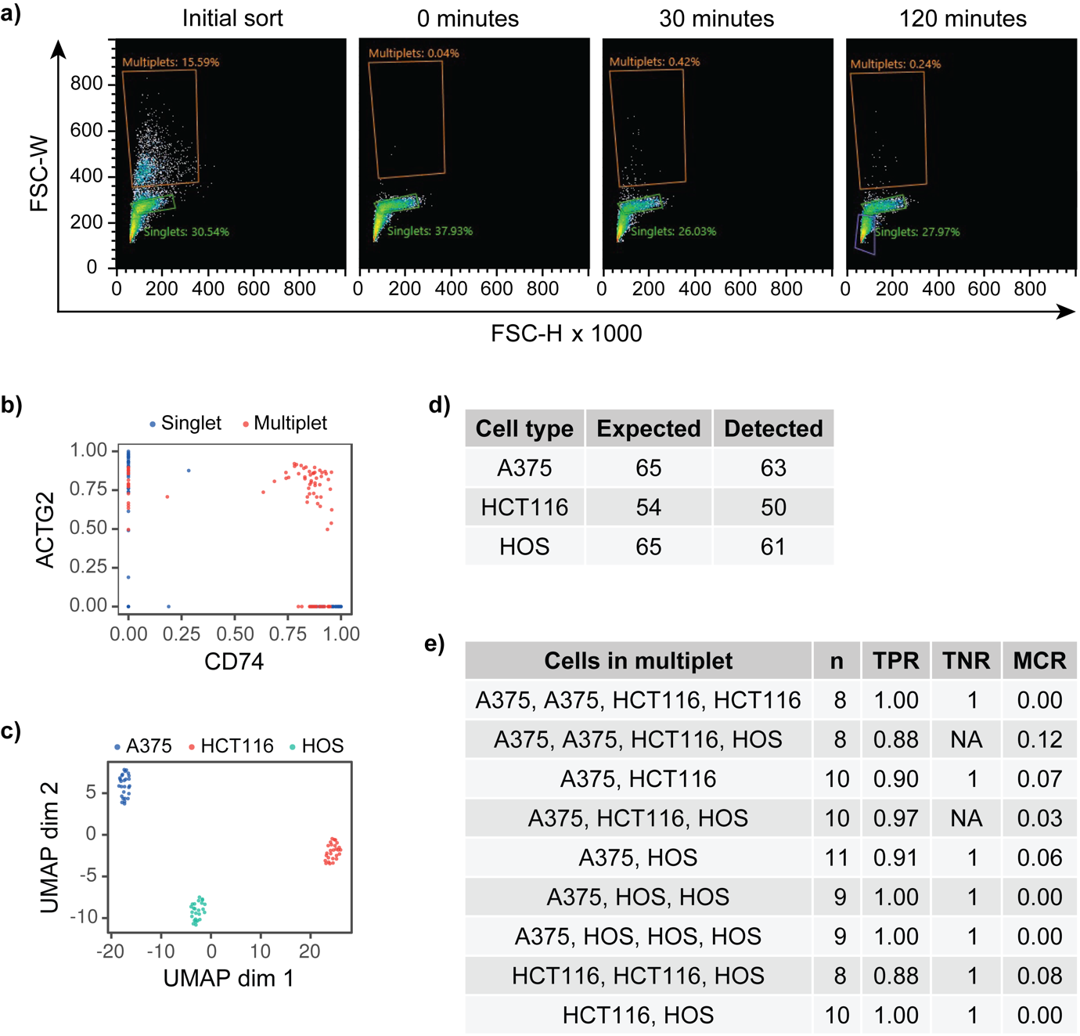

**Extended Data Figure 1. a)** Flow cytometry analysis of re-association rate. HCT116 singlets and multiplets were sorted separately and singlets were re-analyzed after 0, 30, and 120 minutes. **b)** Analysis of A375 (CD74) and HOS (ACTG2) specific marker expression in singlets and multiplets shows co-expression is only observed in multiplets. **c)** Dimensionality reduction (UMAP) and unsupervised classification of the sorted cell line singlets. **d)** Numbers of expected (sorted) and detected (deconvoluted) cell types in cell line-based multiplets of a known composition. **e)** Cell line-based multiplets of a known composition results showing the number of samples (n), true positive rate (TPR), true negative rate (TNR), and misclassification rate (MCR) for each multiplet composition.

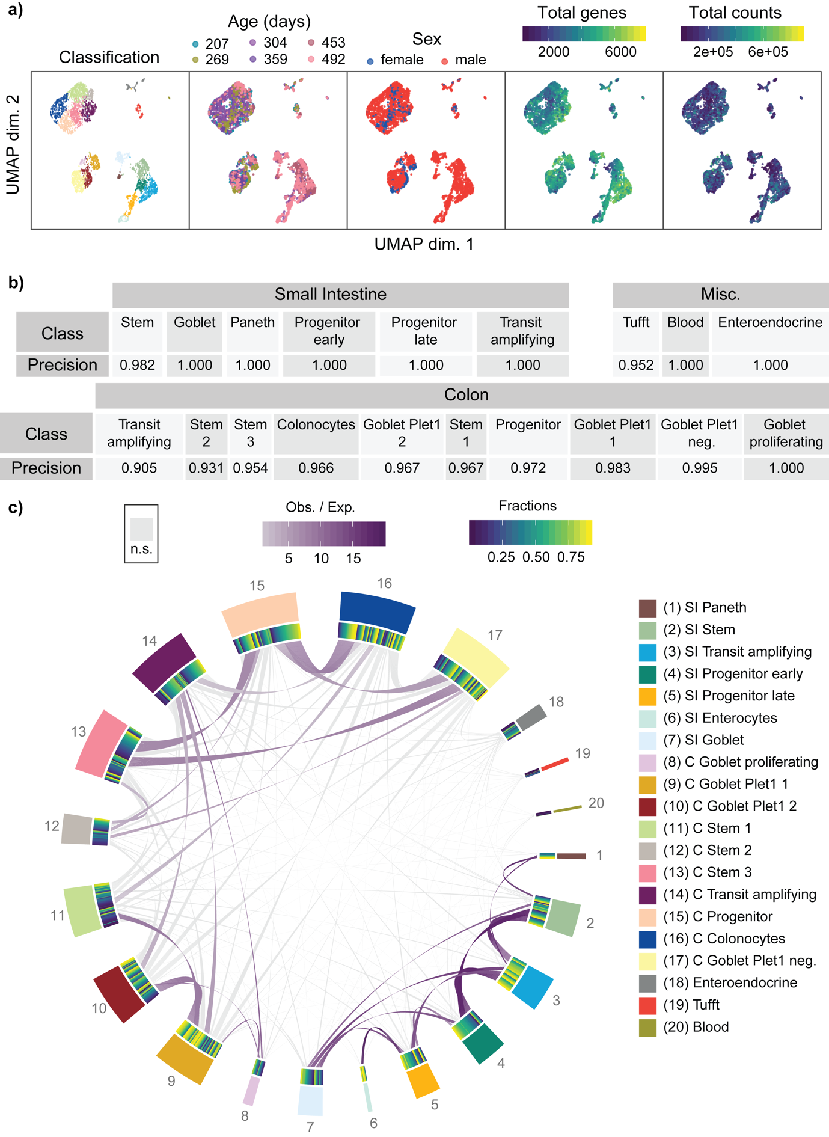

**Extended Data Figure 2. a)** Covariate analysis in mouse gut dataset showing a lack of correlation between covariates and classification. **b)** Deconvolution of mouse gut singlets shows a high precision for all classes indicating the validity of the classification and sufficiency of the provided features to allow discrimination between the different cell types. **c)** Deconvolution of the entire mouse gut dataset indicates a lack of enriched cross-tissue connections and thus implies a low false positive connection rate.

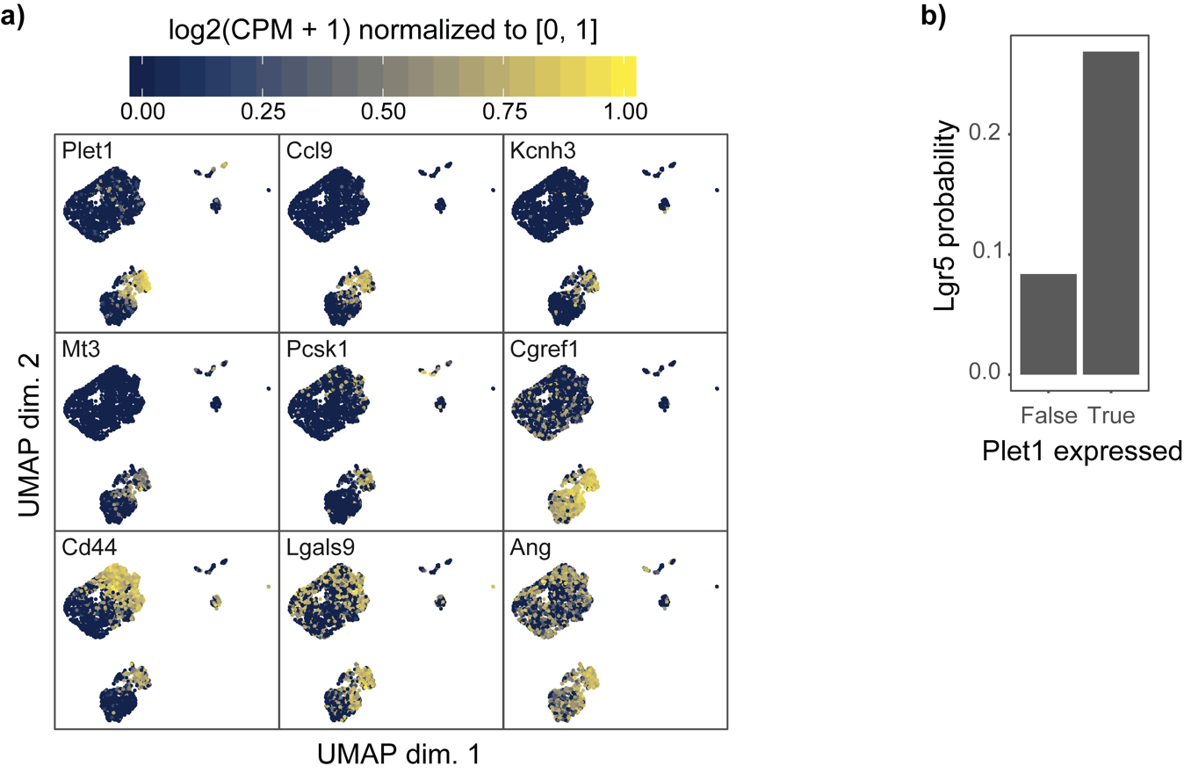

**Extended Data Figure 3. a)** Plet1 differential expression genes, log2(CPM + 1) normalized to [0, 1], overlaid on the colonic epithelium UMAP. **b)** The probability of observing Lgr5 expression in Muc2+ goblet cells dependent on Plet1 expression.